**CHAPTER 1**

**CHAPTER 1**

**INTRODUCTION**

* 1. **INTRODUCTION:**

The aim is to prevent the accidents by providing ultrasonic transceiver in roadways at necessary places such as diversion zones, hair-pin bends, and other accident-prone zones for indicating about the respective places well in advance before reaching the appropriate location vehicle with LED indication and as well as by an Android message display. The accidents due to the carelessness of the driver are prevented by alerting him through the buzzer and light indication as well by voice recognition. Similarly, if the traffic occurs due to the repair or accidents of the vehicle, the transceiver sends the signal to the controller through the Wi-Fi router and shows the message about the spot where the problem has occurred. Simultaneously if traffic occurs for a long time, an emergency message carrying the location will be sent to the controller room and therefore, emergency help can be provided.

The bar graph Fig.1.1 gives the number of road accidents occurring in major states of India. Among it, Tamil Nadu contributes the first place in the occurrence of major road accidents. A survey says that in India, for every minute, five persons are losing their lives in the accidents.

**Road accidents in major states of India.**

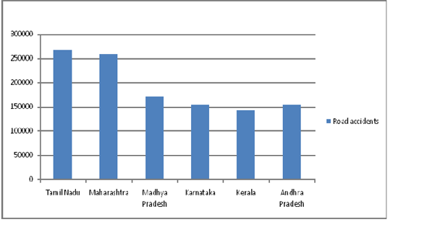

**Fig.1.1: Accidental survey in major states of India.**

**Dept. of ECE, SVIET, NandamuruPage 1**

**INTRODUCTION MOTIVATION**

A life lost in a road accident is unforeseen and absolutely unnecessary. In many accidents, the faults haven’t been recognized and it’s difficult to detect how the problem has occurred.

* 1. **MOTIVATION:**

**S.P.Bhumkar et al** has described the new fatigue detection of a driver and has proposed an intelligent car system for accident prevention.

**D. Haripriya et al** has described the prevention of road accidents occurred due to the poor indication of sign boards, drowsy state and drunken state of drivers in both two wheeler's and four wheeler's.

**S.Uvaraja et al** has described the number of accidents involving the train and has proposed a system that aims at averting collisions between trains and furthers it is used to provide the information on obstacles present in the track to the driver.

**K.P.Sreevishakh et al** has proposed an automatic accident prediction and the notification system using AMR and Sonar sensor.

**Apeksha S. Chavan et al** has described the prevention of accident due to drowsiness of the driver and disturbing intruders.

**1.3 PROBLEM DEFINITION:**

**1.3.1 Existing System:**

The mirror setup arrangements are made in the short bends and corners for viewing the approaching vehicle on the other side. However, it has several drawbacks. The mirror may get damage because of animals (in hills) or it doesn't reflect the image when the climatic condition occurs like raining or covered with mist, etc also when the number of vehicles approaching one after other, it wouldn't be visible for the back-forth vehicle to see the opposing vehicle in corners.Also, there are several methods available for the fatigue prevention of the drivers and detection techniques using alcohol impact, accelerator, brake, clutch, etc. But there is no proper solution for making other road users to take a safe turn in corners.

**Dept. of ECE, SVIET, NandamuruPage 2**

**INTRODUCTION PROBLEM DEFINITION**

**1.3.2 Disadvantages of Existing system:**

Currently, the following methods are being incorporated to negotiate a hairpin bend on a Hilly track, Ghats or any other kind of zero visibility turns.

*A. Vehicle Horn*

This is one of the traditional ways to negotiate a hairpin bend. The drivers on both sides judge the distance of one another based on the intensities of sound from their respective horns. This method although being the simplest poses to be highly inefficient also causing a lot of confusion between the drivers.

*B. Headlights*

Flashing headlights during the night works similar to the vehicle horn making it yet another inefficient method. Also this method is completely ineffective in day light conditions.

*C. Convex Mirrors*

This setup is most widely used nowadays to give a glimpse of any vehicle approaching the hairpin bend from the opposite end. But, these have their shortcomings such as the mirror needs to be kept clean at all times which is difficult in hilly areas as its always cold and misty, thereby reducing its visibility. Also the time taken for the driver to view the mirror and react is high resulting in a poor judgement in return resulting in a mishap.

**1.3.3 Proposed System:**

R. S. Rahul et al in have proposed a model to implement the vehicle mishap averting system using microcontroller. Through Wi-Fi a signal is transmitted to driver about the traffic and vehicle arrival on the other bend followed by a buzzer on the hairpin bends.

Jessen Joseph Leo et al in talks about an inbuilt system in vehicles using GPS technology which takes care of location of the vehicles with respect to the

hairpin bend to decide the priority in which the vehicles have to move. The main disadvantage of this method is the complexity in installing the system in all vehicles and communication between the vehicles in hairpin bends.

**Dept. of ECE, SVIET, NandamuruPage 3**

**INTRODUCTION OBJECTIVES OF PROJECT**

EiEi Thwe in gives an idea to reduce the accidents and safety measuring techniques in hairpin bends using obstacle detection system. A GUI (Graphical User Interface) is developed to monitor and control the system which detects the obstacles within 13 feet range of the vehicle using ultrasonic sensors.

**1.4 OBJECTIVES OF PROJECT:**

The objective was to replace road signs with RFID tags, and use in-vehical RFID Reader-enabled modules to sense them, and provide tangible information to the driver. The project being made is such that along with its efficiency other facors like future expansion possibility, cost and availability of components is taken into consideration.

**1.5 ORGANIZATION OF DOCUMENTATION:**

In chapter 2 the overall system block diagram of implementation of vehical mishap averting system using microcontroller.

In chapter 3 the Hardware Design and all its description is explained.

In chapter 4 the Software used is explained.

In chapter 5 the Implimentation is explained.

In chapter 6 the Results are Observed.

**Dept. of ECE, SVIET, NandamuruPage 4**